Moving Music | Sound and Fury
Learning Resource Pack

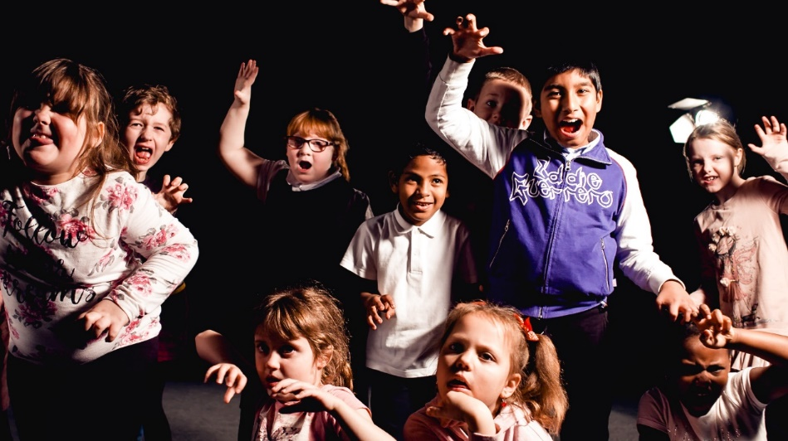

Created by Ana Almeida and the Scottish Chamber Orchestra

Contents

About the Resource 3
What is Moving Music? 3
Moving Music Aims and Scotland’s Curriculum for Excellence 3
Preparation 4
Taking part 4
Health and safety advice for classroom use 4
Video Resources 5
Extension Activities 6
Get Creative with Sound and Fury 6
Create a graphic score 7
Choreograph a dance 8
Appendix 10
Music Glossary 10
Vocabulary 10

About the Resource

This Learning Resource Pack accompanies the Moving Music films for primary school-age children which feature Sound and Fury by Anna Clyne, performed by the Scottish Chamber Orchestra (SCO).

What is Moving Music?

Moving Music is a project designed by Ana Almeida and the SCO which encourages children aged 7- 10 to express and represent - through movement - what they hear in the music, and to explore what they are thinking and feeling.

This pack accompanies a series of five sequential Moving Music videos. We suggest that children watch one Moving Music video per day over the course of a week, then watch the full performance of Sound and Fury and try out some of the extension activities. To enrich the learning we have provided links to background videos about Scottish Chamber Orchestra musicians, conducting, and SCO Associate Composer Anna Clyne.

Moving Music Aims and Scotland’s Curriculum for Excellence

These Moving Music resources support Scotland’s Curriculum for Excellence and are designed for P4 - P6 pupils (ages 7 – 10). They aim to:

Expressive Arts (Music and Dance)
- Encourage active listening and music appreciation
- Introduce children to orchestral music and repertoire
- Develop their music skills and understanding of basic musical concepts
- Promote musical experiences through spontaneous and purposeful movement
- Encourage pupils to translate musical features into movement sequences
- Expand their movement vocabulary and ability to express ideas, thoughts and feelings through creative dance

Health and Wellbeing
- Provide a positive, open and supportive creative environment
- Build children’s confidence in their music and movement abilities
- Encourage pupils to participate and express themselves through creative work
- Respect children’s individual differences, needs and personal choices
- Promote collaboration and respect for other’s ideas, thoughts and feelings

Preparation

We recommend that you explore the videos before you present them to the children
- Note the musical terms and vocabulary used, which can be found in the appendix of this document. You might choose to share the terms and vocabulary with the class in advance of the video viewing
- Background information and videos about the SCO, our conductors, and composer Anna Clyne are on the webpage and can be shared with the pupils at any time: www.sco.org.uk/movingmusic
- We recommend however that pupils watch the full performance video after they have worked through the five Moving Music videos
- Check out the extension activities to help you explore the full performance

Taking part

- Each child must find a ‘special spot’ in the classroom or at home where they can view the video and move to the music. This ‘special spot’ is simply a comfortable space for each child to stretch and twist their bodies, without touching anyone or anything
- All activity can be carried out with minimal space - you just need enough room to move safely on the spot in an uncluttered area
- Every child should be encouraged to participate actively and avoid the temptation to view passively
- We expect children to be creatively inspired by Ana’s suggestions and not worried about having to imitate her every step or movement. There are no ‘right’ or ‘wrong’ responses - all ideas should be welcomed in order to develop confidence, enjoyment and creative expression
- Where necessary you can pause the video and provide additional explanation or replay a movement activity several times

Health and safety advice for classroom use

- Children can take part in the classroom, with no need to relocate to another space (e.g. gym)
- Each child should be encouraged to listen and move to the music on the spot, rather than having to ‘travel’ around the room
- No face-to-face interaction or direct contact is required
- The presenter does not encourage touching or lying on the floor

Video Resources

On the webpage you will find (www.sco.org.uk/movingmusic):
- Five Moving Music videos
- Background videos
- A full performance video of Sound and Fury
- Suggestions for teachers

- Pause the video after Ana introduces musical concepts, to check understanding. You could also mention the opposite concepts (e.g. the opposite of accelerando = rallentando)
- Replay activities as many times as necessary

Extension Activities

Get Creative with Sound and Fury

- Watch the 17-minute video of the SCO performing Sound and Fury. You can find the video on our website page www.sco.org.uk/movingmusic or on our YouTube https://youtu.be/-6pcwUcsgKQ
- While the video plays you will need paper and pens.

PART 1
Watch the first five minutes of the Sound and Fury video and then pause it while you write or draw a list of anything that catches your attention. For example, you might notice

- familiar music
- images, words, thoughts or feelings
- imaginary musical characters
- movements that your body wants to make to the music
- how an instrument is played and how it sounds
- how the conductor moves their hands and body
- the mood (e.g. cheerful, sad, furious, funny)
- how fast/slow the music is and whether it becomes gradually faster (accelerando) or slower (rallentando)
- how loud/quiet the music is and whether it gets gradually louder (crescendo) or quieter (diminuendo)
- how smooth (legato) or spiky (staccato) the music is

PART 3
Reflect on your listening experience. What were you thinking about? What did you notice? Then share your stories and pictures with the rest of the class or with your family, if you are at home.

PART 2
Write a story and/or draw a picture inspired by your list of discoveries
Press play again and write or draw while you listen to the rest of the performance.

Create a graphic score

A graphic score is a fun way of visualising music using pictures or symbols. You will need paper and pens.

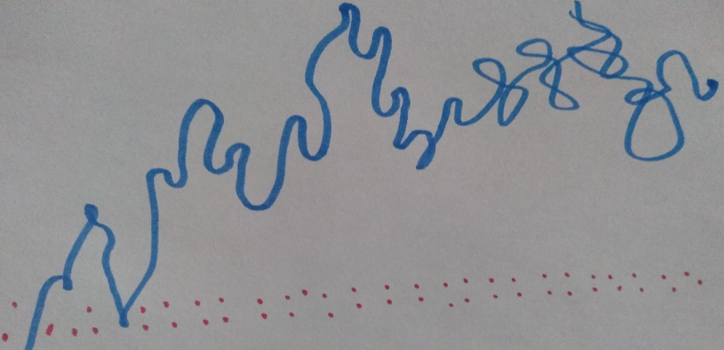

An example of a graphic score representing the ‘Smooth and Spiky’ musical section

- Start by listening to the themes of each musical character from Film 4 (see timings below).
SOUND AND FURY BY ANNA CLYNE
Find the film here: https://youtu.be/-6pcwUcsgKQ
- ‘Baddie’ theme 06’24’’ - 06’46’’
- ‘Bouncy kid’ theme 10’56’’ - 11’07’’
- ‘Warrior’ theme 04’28’’ - 04’41’’

- With your eyes closed, try to see the music in your mind (e.g. dots, lines, shapes, textures, colours, symbols, etc).
- Choose your favourite musical theme (‘Baddie’, ‘Bouncy kid’ or ‘Warrior’).
- Listen again to your favourite theme and while you listen, ‘draw’ the music in the air with an imaginary pencil. Your aim is to ‘draw’ the music, not a picture of the character.
- Now replay your favourite theme a few times while you draw the music on paper. Remember, you can use any shapes, lines, symbols or pictures you like.
- You have now created a graphic score! Play your favourite theme again and trace your graphic score with your finger as you listen.

Choreograph a dance

You could create a short dance inspired by your favourite musical example from Sound and Fury. You will need paper and pens.
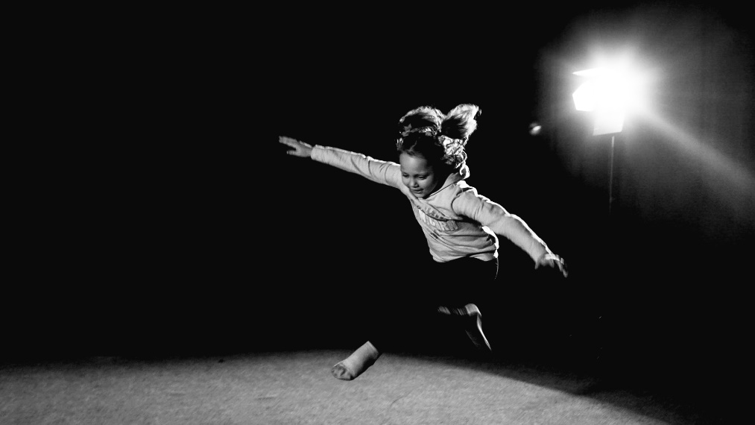

- First, decide which musical example you like best. We have listed some suggestions below with video timings, or you can choose your own section lasting around 30-60 seconds.

SOUND AND FURY BY ANNA CLYNE
Find the film here: https://youtu.be/-6pcwUcsgKQ
- Bubbles theme from Film 1 10’29’’ - 10’57’’
- Angry Shapes theme from Film 2 00’18’’ - 00’47’’
- Smooth and Spiky theme from Film 3 11’07’’ - 11’32’’
- ‘Baddie’ theme from Film 4 06’24’’ - 06’46’’
- ‘Bouncy kid’ theme from Film 4 10’56’’ - 11’07’’
- ‘Warrior’ theme from Film 4 04’28’’ - 04’41’’
- Stormy wind theme from Film 5 16’07 - 17’05’’

- Listen to the music a few times and notice what you think and feel. For example, words, stories, images, feelings, actions, characters, etc.
- Write or draw your ideas on paper.
- Then, find a special spot. Do not play the music just yet, just explore your thoughts and ideas by moving your body (e.g. ‘the music made me think of a slow, lazy, funny creature’).
- Now play the music again and try out your movement ideas as many times as you like. Decide which of your ideas will work best for a short dance.
- Go through your best movements and check if you have explored:
  - the front, back and sides of your ‘space bubble’
  - high, mid and low levels
  - different body actions (reaching, stretching, twisting, etc.)
  - fast, moderate and slow speeds
If not, can you add some of these features?
- Now, structure your dance (‘choreography’) in three parts (beginning, middle and end). Then, repeat and practice your dance several times as you replay the music.
- After you have practiced your choreography, why not share it with your family or your teacher!

Appendix
(feel free to share these with your class)

Music Glossary

Term | Meaning
Melody | A succession of different sounds in a piece of music that are sung or played one after another. The word ‘tune’ is often used informally in reference to the term ‘melody’.
Legato | To sing or play music smoothly. The notes are connected and blended together.
Staccato | To sing or play music sharply. The notes are short and detached.
Crescendo | The music becomes gradually louder. Diminuendo is the opposite term meaning that ‘the music becomes gradually quieter’.
Accelerando | The music gets gradually faster. Rallentando is the opposite term meaning that ‘the music gets gradually slower’.

Vocabulary
