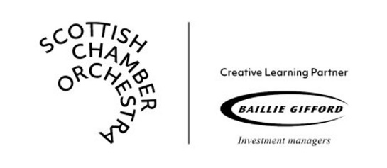
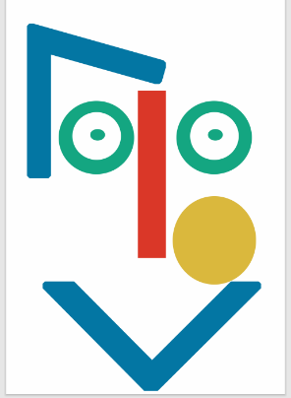
Created by Caroline McCluskey in collaboration with Ana Almeida and the Scottish Chamber Orchestra
Dots & Lines
Learning Resource Pack
Contents
Introductory Films 3
Music 3
Dance & Art 3
Score 4
Art Films 5
Mr Red Line 5
Different Faces 5
My Face 6
Dance Films 6
Statues 6
Guessing Game 7
Going for a walk 7
Music Films 8
Dots & Lines Song 8
Arbeau 8
Sound Explorations 9
Musical Play Films 10
Ms Crescent 10
Mr Blue Circle 10
Credits 11

Introductory Films
Learning Bubble
Listening and observing
Sharing ideas with others

Music
What do different kinds of dots and lines sound like in music? You can listen to the music in this film for enjoyment and to start conversations about what we can see and hear.
Extension Ideas:
What other pieces of music could Dorothy and Lily use for small dots or neat dots? Twinkle Twinkle Little Star? Dance of the Sugar Plum Fairy by Tchaikovsky?

Dance & Art
Learning Bubble
Listening to music and responding in movement
Creative movement explorations
You will hear the music from ‘Dots & Lines in Music’ once again. When guiding a dance or art activity you may wish to follow the same order of music, or you may wish to focus on a particular dot or line.

Dance Activity
You will need
A large, clear space to move in

Paper and drawing materials for artwork

How can we make small dots with only our fingertips… noses... elbows… knees…?
Art Activity
Let’s create a special dots and lines musical score! In the video we demonstrate with extra-large white paper and chunky chalks, but you can use whatever resources you like. You could structure the activity as a collaboration with everyone drawing on the same piece of paper, or as an individual exploration. Why not listen to the Dots and Lines music as a sound file while you are drawing? https://soundcloud.com/user-103359947/sets/dots-and-lines-music/s-Z2WvFbj69Rh

Score
Learning Bubble
Colour and shape
Improvising with the voice
Creative play with musical sounds
Representing musical sounds visually
High and low sounds
Loud and quiet sounds
CC
Colour and shape
Fast sounds and slow sounds

Dorothy Dot and Lily Line share their special dots and lines music. Use your own voices to make the sounds of the ‘blue messy dot’ and the ‘red zigzag line’.

Art Films
Learning Bubble
Observing and copying Mr Red Line’s Face
Creating new faces through exploration
Thinking about expressions and emotions

Mr Red Line
Copy Mr Red Line’s face in time to music.

You will need
Paper and drawing materials for artwork

Different Faces
We create Mr Red Line’s face using paper shapes and play with the shapes to create new faces and different expressions.
How can we describe these new faces? Are they bewildered, happy, excited or grumpy?
Tips
A paper face handout can be downloaded from our ‘Resources’ link to help with making your own interesting faces

My Face
Learning Bubble
Observing the shapes within our faces
Creative drawing of our own faces
Exploring expressions
Ms Chalk takes a closer look at the shapes within her own face before creating a self-portrait.
You will need
A mirror for each child. We use small plastic mirrors that have been carefully mounted onto the card and taped around the sides to avoid any sharp edges.

Dance Films

Statues
Learning Bubble
Listening to music and responding in movement
Exploring sound and silence/movement and stillness
Ms Chalk leads us in the traditional game musical statues. Together we can make different dots and lines shapes with our dancing bodies.
You will need
A large, clear space to move in

Learning Bubble
Observing a dancer respond to music
Creative thinking

Guessing Game
Watch Ms Chalk very carefully as she embodies different kinds of dots and lines. Can you guess which ones she is imitating?

Learning Bubble
Vocal chanting
Keeping a pulse in the feet
Rhythm of the words in speech
Following a leader in teamwork
Working with pitch and dynamics

Going for a walk
For this activity, children can make a line or a train to ‘follow the leader’.
Extension Activity
The line leader and group can decide on the pathway of their journey before they begin.
Will they walk in straight lines or wavy lines?

Will they trace the shape of a square or circle as they march?

Music Films

Dots & Lines Song
We invite you to sing along with us as we recall some of our favourite dots and lines. If you use these resources in the classroom during COVID-19, please adhere to current guidance on singing in schools at the time of use.
Lyrics
Big Dots, Small Dots, Teeny Weeny Polka Dots,
Long, Tall, Wavy Lines,
Big Dots, Small Dots, Follow Me,
A line is a dot that went for a walk…

Arbeau
Learning Bubble
Following a rhythmic pattern
Working with the chanting voice and drawing the notes in movement
Observing a graphic score
Noticing that some sounds are longer than others
Enjoy making music together! In this arrangement of Arbeau’s piece ‘Air des Bouffons’ we can imagine different patterns of dots and lines.
You will need
Print out a copy of the Arbeau score from the webpage. (The top two flashcards are repeated four times. The following four flashcards are repeated twice.)
Frame drums and claves if you have them.

We can join Ms Chalk with our chanting voices and our dancing hands as we respond to the patterns of the music. We can also join in by playing these rhythmic shapes on a frame drum or with claves.

Photo: Arbeau Graphic Score

Extension Activity
This graphic score is one way to describe Arbeau’s music visually. In what other ways could we draw this music?

Sound Explorations
Learning Bubble
Noticing the different sound qualities/timbres of each instrument
Musical imitation
Call and response
Varying dynamics (volume) and tempo (speed)
Creative music making and musical play
Explore different sounds and rhythms made by the same instrument. This activity can work well in a call and response manner, with one person leading and the group responding.

Use imagery to explore sounds: How can our voices make the sound of the wind, crunchy leaves underfoot or a floating cloud?
You will need
Simple percussion such as frame drums - or hands and voices!

Musical Play Films
You will need
Stretchy material

Ms Crescent
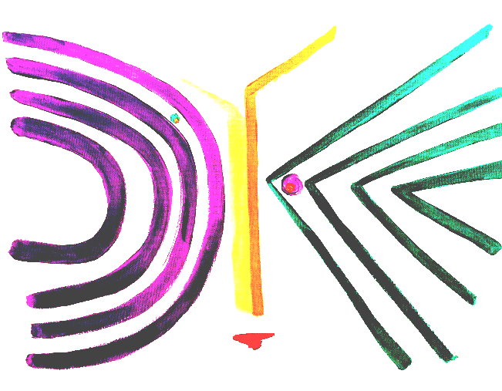
Let’s play with some stretchy material as we listen to the music and copy Ms Crescent. Listen carefully to help guide this activity!
Learning Bubble
Listening to music and responding
Musical anticipation and humour
Following a musical phrase

Mr Blue Circle
Learning Bubble
Listening to music and imagining a multisensory experience
Group storytelling with music
Connecting with the senses of sound, sight and smell
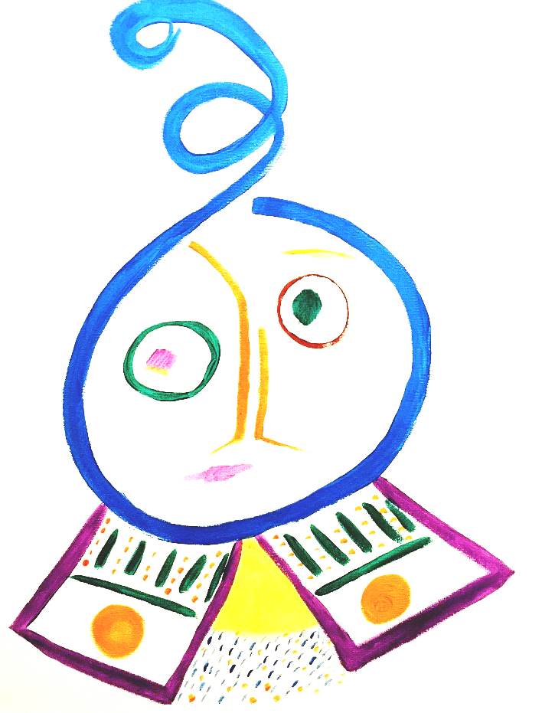
‘Mr Blue Circle’ is an opportunity for listening and relaxing.

Extension Activity
We have included a sound file of Mr Blue Circle’s music without the story so that children can create their own version

Credits
Introductory Duet 1 | Pizzicati Polka from Sylvia | L. Delibes arr. Jimena de Vicente Alvarez and Aisling O’Dea
Introductory Duet 2 | Turkish March from Elementary Duos op.86 no.7 | J. F. Mazas
Big Dots | Rondo from Douze Petite Violin Duos op.70 no.1 | J. F. Mazas
Small Dots | excerpt from Carmen Suite no. 2: La Garde montante. Allegro (Act 1) | G. Bizet
Neat Dots | Das klinget so herrlich from The Magic Flute | W. A. Mozart arr. Jimena de Vicente Alvarez and Aisling O’Dea
Messy Dots | Un poco presto from Sechs Duette op.27 no. 1 | J. Stamitz
Long Lines | Romanze from Sechs Duette op.27 no. 3 | J. Stamitz
Short Lines | Allegro from Sonatas for 2 flutes or violins op. 2 no. 1 | G. P. Telemann
Wavy Lines and Zigzag Lines | Filip's Freylekh | Caroline McCluskey and Martin Fell
Lively and Jovial Music | Fairy Dance | Scottish trad. arr. Aisling O’Dea
Lively and Jovial Music | Jack Tar's hornpipe | Irish trad. arr. Jimena de Vicente Alvarez
Lively and Jovial Music | Allegro from Sechs Duette op.27 No. 2 | J. Stamitz
Mr Red Line | Caroline McCluskey (arr. M. Fell)
Mr Blue Circle | Caroline McCluskey (arr M. Fell)
Ms Crescent | Caroline McCluskey
Dots & Lines Song | Caroline McCluskey (arr K. Davidson-Kelly)
Air des Bouffons | Arbeau (arr C. McCluskey)
Live improvisations by Jimena de Vicente Alvarez and Aisling O’Dea
Dots & Lines artwork created by Caroline McCluskey

